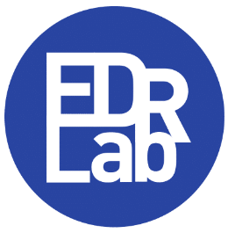 European Digital Reading Lab

Readium LCP information form

Thank you for your interest in integrating Readium LCP in your ebook / audiobook delivery platform.
The European Digital Reading Lab is a non-profit membership organization, focused on the deployment of open, interoperable, and accessible digital publishing technologies. Among other projects, EDRLab oversees the maintenance of LCP related open-source software. It is also in charge of the secure transfer of LCP related confidential information to trusted integrators. EDRLab offers support to these integrators and certifies LCP-compliant software.

Such services impose the payment of a licensing fee. The annual LCP licensing fee will be calculated from your annual gross revenue (or budget for non-profit). Please provide this information below.

Please complete this form, sign it & return it to EDRLab at lcp@edrlab.org

Name of the organization:
Main contact:
Web site
Address:
…
Email:
Phone:
VAT number (EU) or SIRET (France)
Twitter name (optional):
Please tell us more about your organization:
Which category describes your organization best? | e-distributor  Bookseller  Public Library  ________________________
What is the current number of employees of the organization?
What is the annual gross revenue of the organization, or its annual budget if non-profit?
(in € or USD)
How did you know about EDRLab and LCP?

Please tell us more about your use of LCP:
Will you set up an LCP server?
Will you use the open-source Readium LCP Server software?
Will you develop LCP compliant applications? | iOS  Android  Windows, MacOS, Linux  Warning: Web apps are not compatible with LCP.
Will you use the open-source Readium Mobile toolkit for your mobile apps?

From January 2024, becoming an EDRLab member will be mandatory to have access to the Readium LCP technology.
By becoming member of EDRLab, you will help us develop open-source Readium and EDRLab software and participate in the creation and evolution of open standards for the publishing industry. You will participate to working groups, webinars, get news about what happens in the digital landscape and get discount if you participate to the Digital Publishing Summit.
EDRLab membership fees are public, please have a look at https://www.edrlab.org/become-a-member/ to get detailed information.
Note: your EDRLab membership fee and LCP licensing fee will be treated via two different invoices.
If you have already decided to adopt LCP:
WHICH PAYMENT METHOD DO YOU PREFER?
Credit Card Bank transfer Chèque (France) Other________________

Signature:

